CCNA Exploration Chapter 9 EIGRP. Study questions.

9.1
What type of routing protocol is EIGRP?

It is a Cisco proprietary, classless, distance vector routing protocol.

What routing algorithm does EIGRP use?

Diffusing Update Algorithm (DUAL)

Does EIGRP use TCP to provide reliability of transport for updates?

No. It uses its own proprietary RTP (reliable transport protocol) for both reliable and unreliable transport.

Why was IGRP developed in 1985?

To produce a routing protocol that was not limited to 15 hops, and that used a better metric than hop count.

What limiting features of IGRP led to it being replaced by EIGRP?

IGRP is classful. It uses the traditional distance vector Bellman-Ford algorithm and sends regular periodic routing updates.

Why does IGRP need to send regular routing updates of its whole routing table while EIGRP does not?

IGRP routes will time out and are removed from the routing table unless they are refreshed. EIGRP routes do not time out and so do not need regular refreshing.

What do IGRP and EIGRP do if a route becomes unavailable?

IGRP must wait for the next routing update to see if a new route has been found. EIGRP keeps a separate topology table containing backup routes if any exist. A backup route can be put in the routing table as soon as the original route becomes unavailable.

EIGRP converges faster than IGRP because it does not need holddown timers. Why does IGRP use holddown timers, and why can EIGRP manage without them?

IGRP uses holddown timers to prevent the development of routing loops. EIGRP’s DUAL algorithm calculates loop-free paths and does not need other methods of preventing routing loops.

What is TLV?

Type/Length/Value, the name given to the EIGRP data field.

What IP destination address is used by EIGRP messages?

Multicast 224.0.0.10

What are the four types of EIGRP message?

Update, Query, Reply, Hello

What part of the packet specifies the message type?

The opcode in the EIGRP header.

What is the purpose of the AS number in an EIGRP message?

It specifies the EIGRP process. It is possible for a router to run more than one EIGRP process at the same time.

In the TLV part of an EIGRP message, what is the purpose of the K1, K2, K3, K4, K5 numbers?

They specify how the routing metric is to be calculated.
K1 is the weighting for bandwidth, 1 by default.
K3 is the weighting for delay, 1 by default.
K2, K4 and K5 are 0 by default.

What is the purpose of the holdtime in the TLV part of a EIGRP message?

It gives the number of seconds that a router should wait before considering that a neighbour router is down if it does not receive any hello messages from the neighbour.

What are EIGRP internal and external routes?

Internal routes are routes where the information originates within the autonomous system – the EIGRP process. External routes are imported into the EIGRP process from elsewhere. They may be imported static routes, they may be imported from a different routing process or from a different autonomous system.

How is delay calculated?

Delay is calculated as the sum of delays from source to destination in units of 10 microseconds.

How is the bandwidth metric found?

Bandwidth is the lowest configured bandwidth of any interface along the route. It is not calculated by measuring the real bandwidth of links. If no bandwidth is configured on an interface then it uses a default value.

What services does Reliable Transport Protocol provide?

It can provide reliable transport as TCP does, by using acknowledgements and resending lost transmissions. Where reliability is not needed, it can provide unreliable transport in a similar way to UDP. It is therefore used for EIGRP messages instead of TCP and UDP.

Why does EIGRP use RTP and not TCP or UDP?

Use of TCP and UDP would restrict EIGRP to using the TCP/IP suite of protocols. It was designed to be independent and work with different protocol suites. RTP was created by Cisco specially to be used by EIGRP.

How does EIGRP support different network layer protocols?

EIGRP has a main program that is independent of any network layer protocol. It then has protocol dependent modules, one for IP, one for IPX and so on. It can use the appropriate module to work with the network layer protocol that is in use.

Which EIGRP messages are send reliably?

Update, Query, Reply.

Which EIGRP messages are send unreliably?

Hello, Acknowledgement (ACK).

Which EIGRP messages are sent unicast and which are sent multicast?

Hello are multicast.
Update and Query may be multicast or unicast.
ACK and Reply are unicast.

What is an NBMA network? Is Ethernet an NBMA network?

Non-Broadcast Multi-Access. It is a multi-access network that can have more than two hosts on the same subnet. It does not use broadcasts. Ethernet is multi-access, but it does use broadcasts, so it is not NBMA. Frame relay and ATM are NBMA.

How often, by default, will EIGRP exchange hello packets on an Ethernet network?

Every 5 seconds.

How often, by default, will EIGRP exchange hello packets on a point to point serial link?

Every 5 seconds.

How often, by default, will EIGRP exchange hello packets on a multipoint Frame Relay network operating at less than 1.544 Mbps?

Every 60 seconds.

How long is the hold time for an EIGRP router, by default, and what is its purpose?

Three times the hello interval, so 15 seconds on most networks or 180 seconds on a slow NBMA network. If a router stops receiving hello messages from a neighbour then it waits for this time before assuming that the neighbour is down.

EIGRP updates are partial and bounded. What does this mean?

Partial means that they include only information about the changed route. They do not include the whole contents of the routing table.
Bounded means that updates go only to routers that are affected by the change.

Why should EIGRP use less bandwidth than IGRP or RIP?

IGRP and RIP send updates containing the whole contents of their routing table at regular intervals. Although EIGRP sends frequent hello packets, these are very small. Updates are kept as small as possible and are sent only when a route changes.

Which routers will prefer EIGRP routes to routes found by all other interior routing protocols?

Cisco routers because their IOS gives EIGRP routes a lower administrative distance than routes found by all other interior routing protocols. Non-Cisco routers do not run EIGRP.

If EIGRP is configured for authentication, what is encrypted?

EIGRP packets are encrypted. (Routing tables are not.)

9.2
What is the “autonomous system number” used in EIGRP configuration?

It is a process number to distinguish between different instances of EIGRP in case a router is running more than one.

What is a real autonomous system number, and which routing protocol uses them?

It is a number assigned to an ISP, Internet Backbone provider or certain large organizations. It refers to a group of networks that are under a common administration for routing purposes. Border Gateway Protocol, which is an exterior routing protocol, uses AS numbers, and routes between autonomous systems.

How do EIGRP routers become adjacent, and what does this mean?

Routers become adjacent to their immediate neighbours if they exchange hello messages that contain the same AS numbers. Once routers are adjacent, they are able to exchange updates, queries and replies.

Why would a wildcard mask be used when configuring an EIGRP network command?

To restrict routing information to certain subnets of a classful network.

Which wildcard mask is the equivalent of subnet mask 255.255.0.0?

0.0.255.255.

Which wildcard mask is the equivalent of subnet mask 255.255.240.0?

0.0.15.255.

Which wildcard mask is the equivalent of subnet mask 255.255.255.128?

0.0.0.127.

Which wildcard mask is the equivalent of subnet mask 255.255.255.192?

0.0.0.63.

What happens if you include the subnet mask in a network command instead of the wildcard mask?

Some routers will accept this and convert it to the wildcard mask for you. Other routers will not accept the command. It depends on the IOS version.

What information can you get from the command show ip eigrp neighbor?

Order in which neighbours were learned
The IP address of the neighbour.
Interface leading to neighbour
The current hold time. (Counts down to 0. Reset to maximum when Hello arrives.)
Time since neighbour was added to neighbour table
Smooth Round Trip Timer and Retransmit Interval used by RTP.
Queue Count - Should be 0.
Sequence Number to track updates, queries, and reply packets.

If a neighbour does not appear in the neighbour table, what should you check before troubleshooting the EIGRP configuration?

Check that the interface is up.
Check that the neighbour will respond to a ping.

What letter is used in a routing table to show routes learned through EIGRP?

D (for DUAL)

How can you stop EIGRP from summarising routes automatically at class boundaries?

No auto-summary

A routing table includes:
192.168.10.0/24 is variably subnetted, 3 subnets, 2 masks
D 192.168.10.0/24 is a summary, 00:04:13, Null0
D 192.168.10.4/30 [90/2681856] via 192.168.10.10, 00:03:05, Serial 0/1
C 192.168.10.8/30 is directly connected, Serial 0/1
S* 0.0.0.0/0 is directly connected, Serial0/1

What will happen to a packet addressed to 192.168.10.25?

The address matches the parent route 192.168.10.0/24. It is then compared with the child routes. It does not match 192.168.10.4/30 or 192.168.10.8/30 but it does match the summary route 192.168.10.0/24. It is therefore sent to Null0. That means that the packet is dropped.

What command would stop EIGRP from putting the Null0 summary route in the routing table?

No auto-summary.

What will happen to a packet addressed to 192.168.10.25 if the Null0 summary route is removed from the routing table?

Assume that classless routing behaviour is enabled, as it is by default since IOS version 11.3. The packet will fail to match the child routes of the parent 192.168.10.0/24. It will then be compared with other level 1 routes. It matches the default route and will be forwarded through serial0/1.

Which metrics does EIGRP use by default?

Bandwidth and delay.

Which other metrics can it use if configured to do so?

Load and reliability.

How can the administrator change the way that EIGRP calculates its composite metric?

By changing the K values using the #metric weights tos k1 k2 k3 k4 k5 command.

What are the default values that control how EIGRP calculates its metric?

K1 = K3 = 1. K2 = K4 = K5 = 0.

If the default values are used, how is the composite metric calculated?

Bandwidth + delay.

Which command will show you the K values that are in use?

Show ip protocols

Which command will show the actual values used for bandwidth, delay, reliability, and load?

Show interface (you can then specify the interface, e.g. show interface s0/0)

What is the effect of giving the command:
Router(config-if)#bandwidth 64

The value of 64kbps will be used in calculating the EIGRP metric for that interface. The actual bandwidth of the interface is not changed. You should use the bandwidth command to make the bandwidth used for calculation the same as the actual bandwidth.

What is the usual default bandwidth used in calculating the EIGRP metric on a serial interface?

1544 Kbps (1.544 Mbps). This is the speed of a T1 line.

How does EIGRP find the delay value to use for a link?

The delay is not measured. It uses default values for different types of interface. E.g.
Serial interfaces 20,000 microseconds
FastEthernet interfaces 100 microseconds
These values can be changed.

Where does EIGRP get its values for reliability and load?

These are measured dynamically on the link. Values are 0 to 255.
A
B
192.168.1.1
Bandwidth 64
Delay 20,000
192.168.2.1
Bandwidth 100,000
Delay 100

What is the missing number in the entry in Router A’s routing table?

D 192.168.2.0/24 [90/ ? ] via 192.168.1.2, 00:03:05, Serial 0/0

Bandwidth metric = (10,000,000/64)*256
= 156250*256
= 40,000,000
Delay metric = (sum of delay/10)*256
= (20100/10)*256
= 514560
Bandwidth + delay = 40,514,560
D 192.168.2.0/24 [90/ 40514560] via 192.168.1.2, 00:03:05, Serial 0/0

9.4
In DUAL terminology, what is the feasible distance?

The metric of the best path to a destination. If there are several possible routes then this is the lowest calculated metric. The feasible distance is the metric that appears in the routing table.

In DUAL terminology, what is a successor?

The neighbouring (next hop) router that provides the first stage of the best route to a destination. Its interface address will show in the routing table.

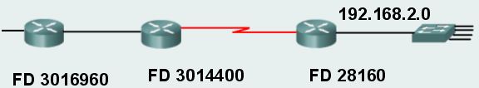

What value does the router on the left have as the RD to 192.168.2.0?

3014400 (feasible distance of neighbour closer to destination.)

What value does the router in the middle have as the RD to 192.168.2.0?

28160 (feasible distance of neighbour closer to destination.)
A
B
D
C
E
F
G
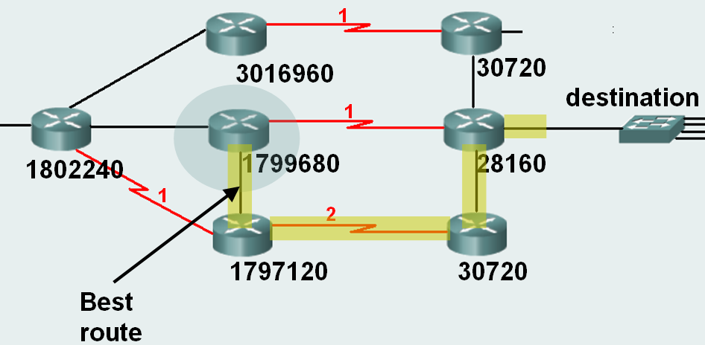

A has calculated the best route to the destination. Which router is the successor?

F

Are there any feasible successors? If so, which are they?

Yes. B reports a distance less than A’s feasible distance so B is a feasible successor. C is not.

Will A keep any backup routes to the destination?

Yes. The route via B will be saved as a backup route.

What will happen if the link between A and F goes down?

The backup route via B will immediately be put into the routing table and used without further calculation.

Where does EIGRP store details of its backup routes, and how can you see them?

In the topology table.
show ip eigrp topology

P 192.168.1.0/24, 1 successors, FD is 3014400
via 192.168.10.10 (3014400/28160), Serial0/1
via 172.16.3.1 (41026560/2172416), Serial0/0
What are the numbers in brackets?
What does P mean?

This is part of the topology table. The first number in the brackets is the feasible distance and the second number is the reported distance.
P is passive. The route is not being actively calculated at the moment. It is stable and can be used.

Which command would give you full details of successor and feasible successor routes to 192.168.1.0, including metrics used in the calculation?

Show ip eigrp topology 192.168.1.0

Which command will show all possible paths to a destination, even if they are not successors or feasible successors?

show ip eigrp topology all-links

What happens if the successor route goes down and there is no backup route to the destination in the topology table?

The router will query its neighbours to see if they have routes to the destination. DUAL will then carry out its calculation of metric based on the new information. If it finds a successor route then this new route goes in the routing table and in the topology table. Any feasible successors go in the topology table as new backup routes. If it does not find a successor route then the destination is removed from the routing table.

What is the name given to a set of possible states, events that lead to the states and events that result from the states?

A finite state machine.

Which command will display DUAL activity as it finds new routes etc.?

Debug eigrp fsm

What address would advertise a single summary route for the networks 192.168.64.0/24, 192.168.65.0/24, 192.168.66.0/24 and 192.168.67.0/24?
A router is running EIGRP with AS number 3.
What command would you give in order to make the router advertise this summary address, and where would you put the command?

192.168.64.0/22
Router(config-if)#ip summary-address eigrp 3 192.168.64.0 255.255.252.0
On each interface that is to advertise the summary.

This line appears in a routing table. What is the origin of this route?
D*EX 0.0.0.0/0 [170/3651840] via 192.168.10.6,
00:01:08, Serial0/1

This route was learned through EIGRP, but it is an external route. It is also a default route. It would have been configured as a static default route on another router, and included in EIGRP updates using the redistribute static command.

What is the purpose of this command, and what do the numbers represent?
Router(config-if)#ip bandwidth-percent eigrp 1 40

It limits the percentage of bandwidth that eigrp messages can use on the configured interface. 1 is the AS number. 40% is the maximum bandwidth to be used.

How would you configure the s0/0 interface of router R6, which is running EIGRP with AS number 3, to use a hello interval of 50 seconds and a holdtime of 150 seconds?

R6(config)#

R6(config)#int s0/0
R6(config-if)#ip hello-interval eigrp 3 50
R6(config-if)#ip hold-time eigrp 3 150

Router R6 has been configured with an altered hello interval on s0/0, which is directly connected to s0/0 of router R7. Does R7 also need to have its hello interval altered?

No. EIGRP does not require that neighbours must use the same hello interval in order to form an adjacency. (There are routing protocols that do.)

